RESTAURENT MANAGEMENT

NAME:M.vignesh , C.midhun

SEC: AI/D

REG: 2111047010205 , 2111047010204

BATCH: D3

AIM: To create restaurant management system using star uml

PROBLEM STATEMENT: To create restautrent management system using class and use case diagrams in star uml and code generation.

FUNCTIONAL REQUIREMENTS:

Problem statement,

Restaurant,

Customer,

Menu,

Order,

Dish,

Manager,

Payment,

Delivery,

# CLASS DIAGRAM:

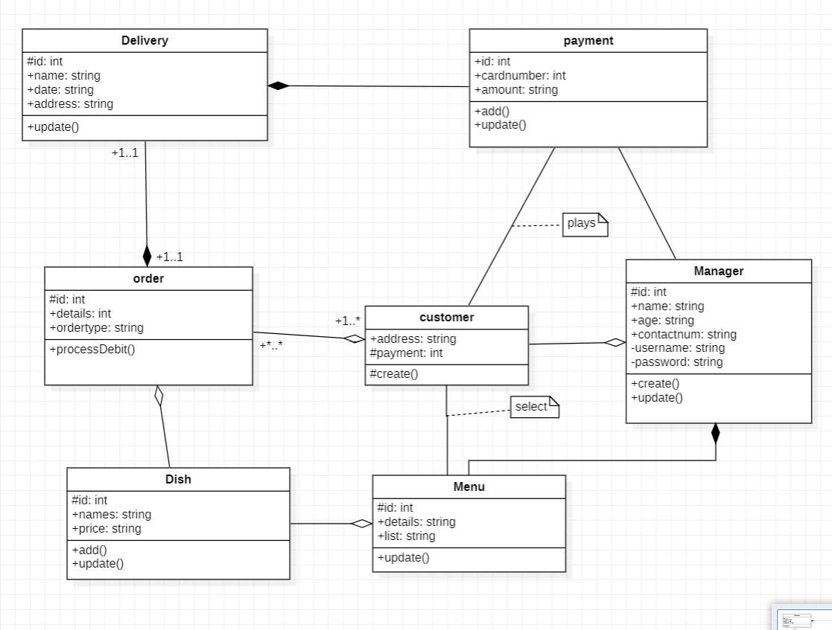

USE CASE DIAGRAM:

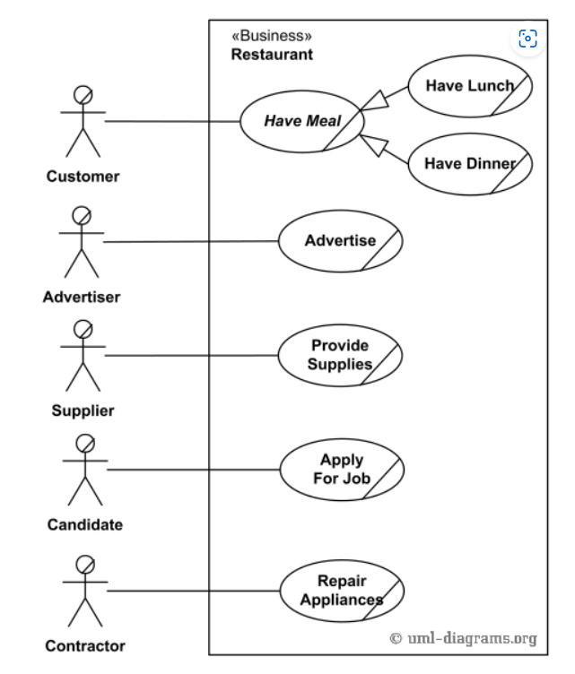

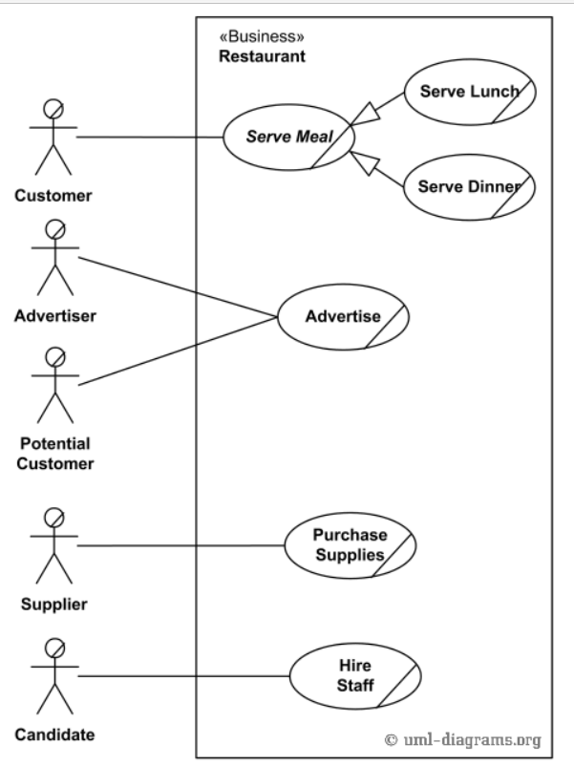

CODE GENERATION:

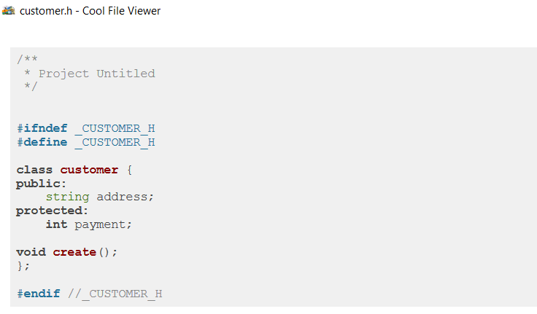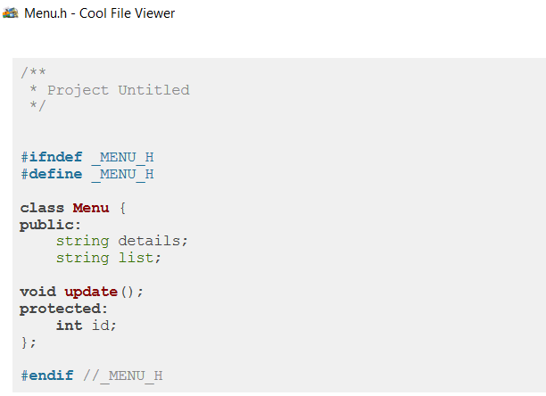

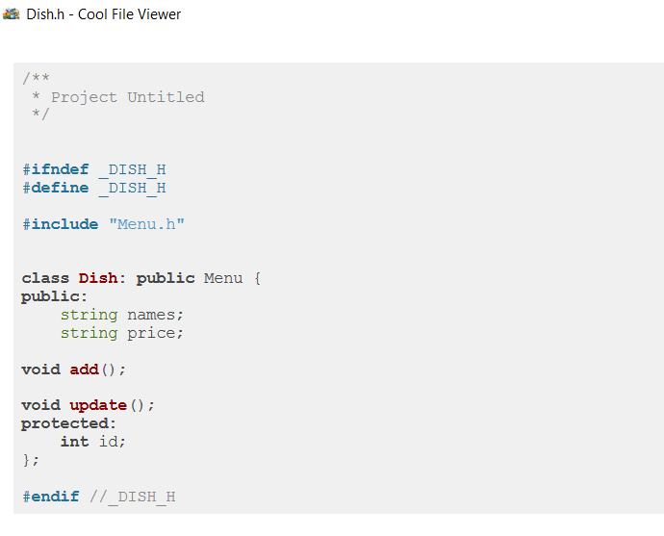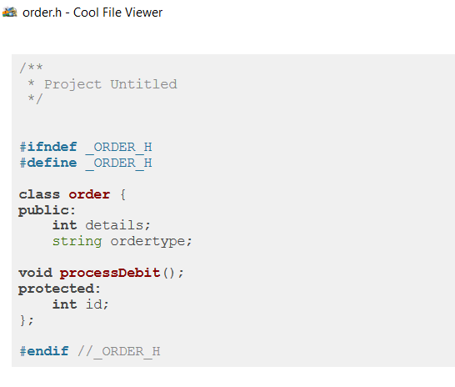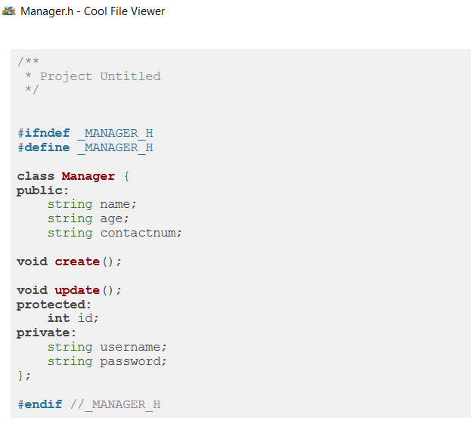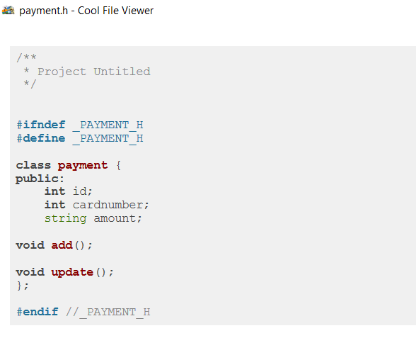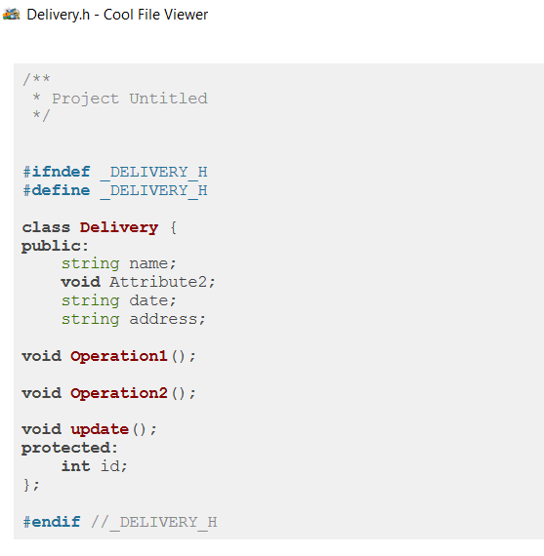

RESULT: HENCE WE SUCCESSFULLY CREATED CLASS AND USE CASE DIAGRAM.